Iambic Pentameter

📏 What is Iambic Pentameter
# Source: Chatgpt (GPT-4-turbo) at [8/2/2025]
Iambic Pentameter is the most common metrical pattern in English poetry. It consists of:
- Five iambs per line (hence "penta" for five)
- Each iamb = an unstressed syllable followed by a stressed syllable
→ da-DUM da-DUM da-DUM da-DUM da-DUM

🧱 Structure
# Source: Chatgpt (GPT-4-turbo) at [8/2/2025]
- 10 syllables per line (5 iambs × 2 syllables)
- Rhythm: × / × / × / × / × /
(× = unstressed, / = stressed)

📝 Examples
# Source: Chatgpt (GPT-4-turbo) at [8/2/2025]
Shall I compare thee to a summer’s day?
— William Shakespeare
To strive, to seek, to find, and not to yield.
— Alfred, Lord Tennyson

🔀 Variations & Flexibility
# Source: Chatgpt (GPT-4-turbo) at [8/2/2025]
Iambic pentameter often includes metrical variations to maintain natural speech flow:
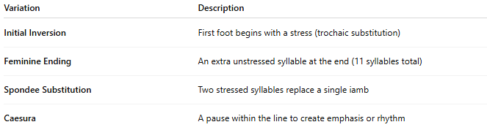
Variation | Description
Initial Inversion | First foot begins with a stress (trochaic substitution)
Feminine Ending | An extra unstressed syllable at the end (11 syllables total)
Spondee Substitution | Two stressed syllables replace a single iamb
Caesura | A pause within the line to create emphasis or rhythm

🧬 Poetic Use & Effect
# Source: Chatgpt (GPT-4-turbo) at [8/2/2025]
- Balances formality with natural speech rhythms
- Ideal for dialogue, monologues, sonnets, and epic poetry
- Offers a musical but flexible rhythm—used for both lyrical and dramatic content

🏛️ Where It's Found
# Source: Chatgpt (GPT-4-turbo) at [8/2/2025]
- Shakespearean sonnets and plays
- Milton’s blank verse (e.g., Paradise Lost)
- Chaucer, Marlowe, Wordsworth, Tennyson, and many others
- Modern verse often retains its cadence even in free verse

